POE Reports

Student Number: | St10058364
Programme Code: | BCA3
Module Lecturer: | Reece Wanig
Module Code: | PROG7312
Date of Submission: | 18-11-2024

I hereby declare that I did not plagiarise the content of this assignment and that this is my own work.
Assignment submitted via SafeAssign: a(Tick the Box)

Table of Contents
1 Implementation 1
2 Project Completion Report 1
3 Technology Recommendations 1

Implementation
For part three the tree structure I went for was a generic tree. Firstly, I will explain how I used the tree structure then explain why I used a generic tree. My tree consists of services requests where each service request can have sub service requests for instance one of my examples is fix Admirality Road which consists of 3 service requests being fix pothole, fix streetlight and fix robot. Each service request has a submission date for when the request was submitted, a description of the request, a request ID, status of how far the request is from completion and the priority of the request, the higher the number the more important the task. So, my tree consists of a parent service request which has children service request which need to be completed for the parent request to be finished. I used a generic tree because it allows for each service request to have as many children requests as it wants without a fixed size, this allows for the different requests to have however many requests needed for the main request to be completed. On the index page for service requests, it uses a function to make a list of every node in the tree which is then displayed in a table where the user can click a button called dependencies which will show which requests the request is dependent on. There is also a search feature which searches the tree for requests based on user criteria.
I used a basic graph to keep track of the relationship between parent and children requests. I made it so that when the tree is made a graph is made also which stores the takes note of the edges between each request and its parent. The parent node will have edges, and each edge is its child node, I refer to the edges as dependencies because each parent request is dependant on its children because only when the children request is finished can the parent request be marked as complete. The dependency page shows which requests the request is dependant on based on the edges it has.

Project Completion Report
Project Overview

Part 1
For part one we had to do research on some user engagement features to keep users engaged in our application, for me I chose a level up feature and a leaderboard feature, I felt that more people would use the app if there was some kind of satisfaction when using it, I felt that the user being able to see their level and where they are on the leaderboard compared to other users could keep them engaged and entertained. We also had to implement a report feature which was pretty fun, I found the progress bar to be a bit challenging, but it was fun to try it out and eventually get it right. The file upload was also a bit difficult, but I got it in the end also.

Part 2
The second part we were required to implement a events feature which will recommend events to the user based on their searches. This part was especially fun because it was the first time we had to make a somewhat complex algorithm. It was a bit tricky but after experimenting which different search parameters I felt that I made a somewhat complex algorithm which I am proud of.

Part 3
For part three the most difficult part was trying to figure out how to implement both trees and graphs into the service request feature. This is because I felt that one or the other could have done it fine on its own because I eventually came up with a solution that uses both by using the characteristics of each data structure’s strength to eventually solve the problem. This being using graphs to keep track of the relationship between parent and child requests by using edges on each child request connecting to the parent request. Another problem I faced I wasn’t sure how to display the data which would make use of both trees and graphs. I eventually chose to make a table out of all the nodes in the tree which has a button for each request which would show which requests needs to be complete before that request is marked complete, this was done with graphs.
The main things I have learnt in this project is how to make algorithms using complex data structures such as trees, graphs, dictionaries, ques and more. I have also learnt more about ui design because being able to show these data structures in a way that people can understand it is important. I have also learnt that patience is key when working with complex data structures because a lot of the time what you are trying to make is not going to work on the first try. I have also learnt the skill of problem solving because a lot of the time when the code doesn’t work you have to read through console errors and try and understand where you went wrong, and this project has taught me how to approach problems correctly.

Technology Recommendations
The main technology recommendations for me are backend implementations. Because I used a C# MVC it would only make sense for it to be hosted as a website. For this you could use Microsoft Azure or Amazon hosting. Another technology which should be used is a database to hold the data. This is because currently all the data is just local data so it would make sense for a database to store it. The database should also then be hosted on a platform such as azure or amazon. Another recommendation would be a mobile app, this project looks to get people to interact with their municipalities more frequently and these days everyone uses their phone for everything, this will allow for users to interact with the municipality more frequently. Lastly an API could be made to allow for easier implementation of backend for each platform whether it be website or mobile device.

Feedback
For part 1 I received no feedback.
For part 2 I received feedback that I should fix my events page and one of the recommendations was to move the announcements to a sidebar rather than have it above the events, I have since implemented a side bar showing the announcements.
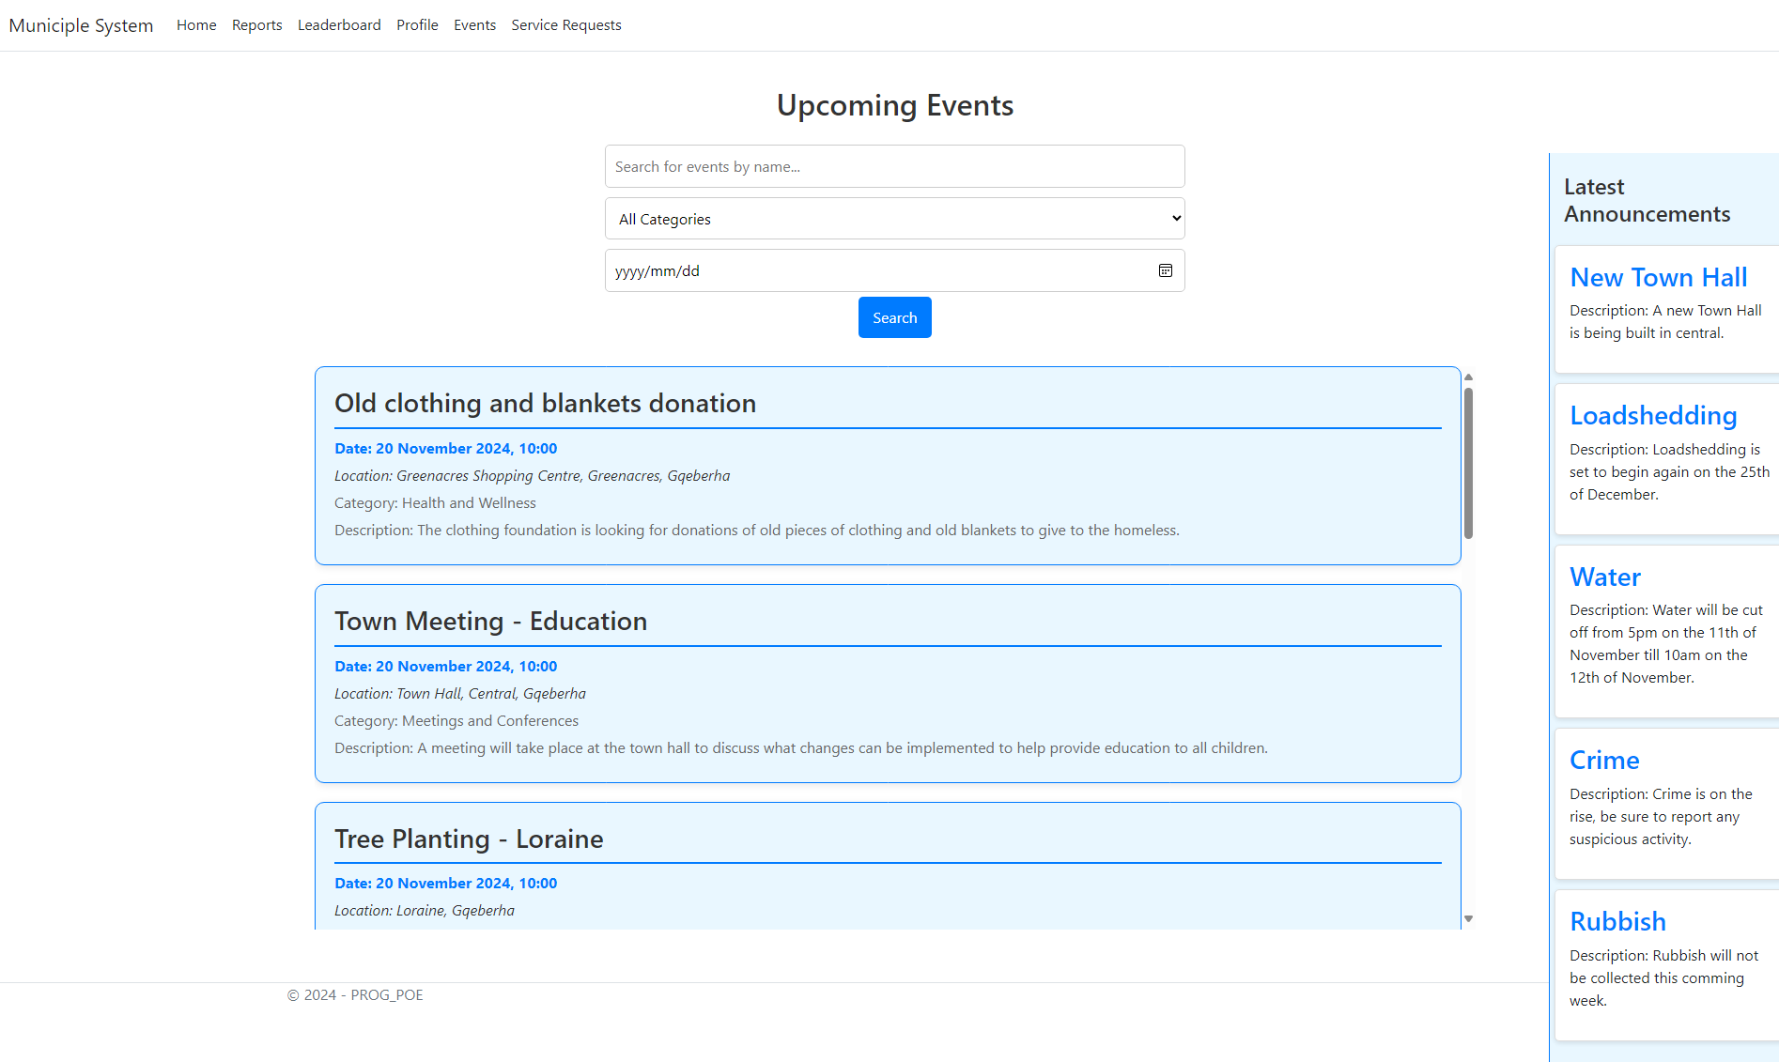
The image looks weird because of the screenshot, please look at the video to see how it looks and makes more sense.

